Reality Television

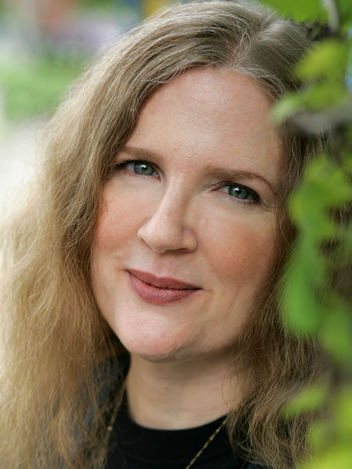

Hypothetical Producer Journal Excerpt:

Week 8,

Today was rather dull; we need something big to draw the crowd to this week’s episode. Make sure he keeps Bianca around for another week, the tension between her and Sarah is building and it’s only a matter of time before they collide.

Personal Diary:

Jan. 6, 2014

It’s finally Monday. Most dread the beginning of the week because it signifies the disappointing reality that there are still four more school days remaining, but that’s not what concerns me. Today is my favorite week day. When seven o’clock comes it is time for my mother and me to watch *The Bachelor****.***  Though it may not be considered a high quality show, I can’t help but tune in every week for each hour long, drama-filled episode.

With no clear industry definition, it can be a challenge to categorize films in the reality television genre, or, rather, it can be easy to overly categorize programs into this genre. For example, depending on whom you ask, reality television can encompass anything from talk shows to competition shows; the premises of these shows vary greatly yet they are often classified together.

“The Hunger Games is a reality television program. An extreme one, but that’s what it is. An while I think some of those shows can succeed on different levels, there’s also the voyeuristic thrill, watching people being humiliated or brought to tears or suffering physically. And that’s what I find very disturbing.”- Suzanne Collins

http://www.glogster.com/anabelromero/suzanne-collins/g-6kt0vb1kft937puqbg9l7a0

Are Reality Shows a Bad Thing?

A big draw to reality television is its ability to allow us to forget the stress of our own lives. We can place our attention on the misfortune of others to aid the pain of our own struggles. Even reality shows that appear harmless, if not beneficial to the participants, are also filled with negativity. It may look as though the producers have the individual’s best interests at heart, but they are often just attempting to gain the sympathetic audience. As Croghan from the *Daily Nebraskan* points out when speaking of shows such as “Extreme Makeover: Home Edition”, “These television shows are doing a disservice not only to viewers, but to people on the show. There isn’t a quick fix to poverty. And using the poor as pawns in not improving their socioeconomic status.”(Croghan).

With researchers at Brigham Young University (<http://news.byu.edu/archive10-may-realitytv.aspx>) discovering that when comparing five reality shows and five non-reality shows, there were 52 acts of aggression in reality shows compared to 32 in non, it is safe to state that reality TV. is an increasingly aggressive genre. Though they may not be advertently violent now, there are certain attributes that can be associated with pain, such as the intense emotional distress the contestants’ experience. The Hunger Games is an example of the potential of these reality shows if we don’t continue to monitor their progression. The series also displays how unrealistic reality shows are by using the game makers to represent the control the directors and producers hold over what we see.

A new reality show premiering on the CW is an example of reality shows that are venturing towards more violence and replicating situations that are similar to *The Hunger Games*. The premise of the show is placing teams of two into a closed off wilderness area, and having the contestants survive off scarce resources for one month as each team attempts to hunt and capture one another. Though they are clearly not hunting to harm one another, the idea of rooting for a team to find and capture the other too similarly relates to ideas of *The Hunger Games*. As Augusta points out in her blog “HG and Philosophy Paragraph,” by reading *The Hunger Games* and becoming invested in the victory of one of its contestants, in a way, we are no better than the residences of the Capital. Producers of reality shows search for sympathetic viewers, and by watching these shows we only encourage their further production.

Be Careful!